AnyTimeFood

Vicky Gupta

# Restaurant Concept

**Restaurant Name & URL**

*AnyTimeFood*

*anytimefood.com*

**Food & drink**

*Food –*

* *Pav Bhaji*
* *Dosa*
* *Misal Pav*
* *Dahi Puri*

*Drink –*

* *Soft / Cold Drink*
* *Fruit Juice*
* *Soda*

**Location**

*Country – India*

*City – Mumbai*

*Neighborhood - Ghatkopar*

**Main target audience**

* Kids (ages 12–16) whose parents work late.

**Cost**

*Affordable.*

* *Morning –*
  + *Food Price – 100 rupees to700 rupees.*
  + *Drink Price – 20 rupees to 120 rupees.*
* *Noon & Evening–*
  + *Food Price – 200 rupees to 1000 rupees.*
  + *Drink Price – 30 rupees to 220 rupees.*
* *Night –*
  + *Food Price – 50 rupees to 1500 rupees.*
  + *Drink Price – 10 rupees to 300 rupees.*

**Elevator pitch**

*Neither less nor more price. We bring the best and delicious food for those all kids as well as teenagers. Your tummy will be satisfied but not your hunger.*

# Strategy

## Target Audience

The website/app will focus on the following target audiences:

**Roles** (groups of people with similar goals)

* **Late-night studier**
* **Foodie**
* **Junk Food Lovers**

**Demographics**

* **Gender** – All
* **Education** – School and College Students
* **Occupations** – Unemployed, Part-Time worker.
* **Age** – 12-28 years old
* **Location** – Urban
* **Marital Status** – Single
* **Income** - Enough

**Psychographics** (personality, values, attitudes, interests, lifestyles)

* **Personality & Attitudes:** 
  + **Smart Worker**
  + **Epicure**
  + **Sleepy**
  + **Lazy**
  + **Well-being**
* **Values:** 
  + **Straight-forward**
  + **Sharp Knowledge**
  + **Loyalty**
  + **Openness**
  + **Respect**
* **Lifestyles/Interests:**
  + **Smart**
  + **Studious**
  + **Love**
  + **Non-smoking**
  + **Non-drinking**

# Strategy

## User Needs

The website needs to enable the user to:

* *Find out if the restaurant delivers to their area*
* *Order food online*
* Find out nearby best and high rated restaurants
* Online Payment Mode or Cash on Delivery Mode
* On Time delivery

## Client Needs

The website needs to enable the client to:

* *To sell food online that will be delivered*
* *Provide a system for order customization*
* Trace whether all foods are delivered on time or not
* Deliver food as same as it was packed
* A satisfied and permanent customer

# Outline of Scope

## Content Requirements

Content (text, images, video) that the user will need.   
*“The user will be looking for…”*

* Nearby Restaurants
* Special Items
* Opening and Closing Times
* High rated Restaurants
* Ratings from other customers
* About Us
* Food Menu with all details

## Functionality Requirements

Systems that will allow the user accomplish tasks.

*“The user will be able to…”*

* Register and Login
* Order customized breakfast / meal / dinner
* Trace Updated order status while delivery
* Online Payment Modes
* Rate Delivery Process

# Sitemap

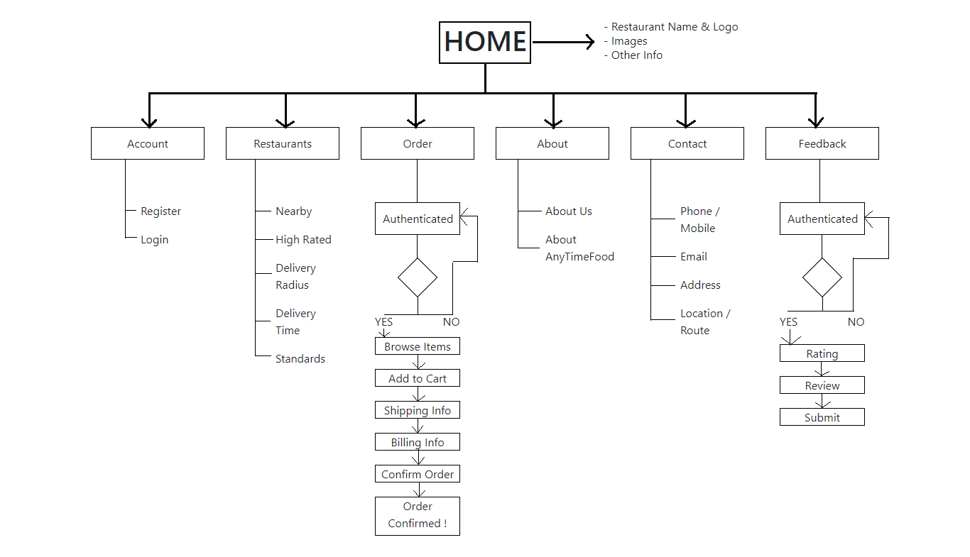

Wireframes – Mobile Version

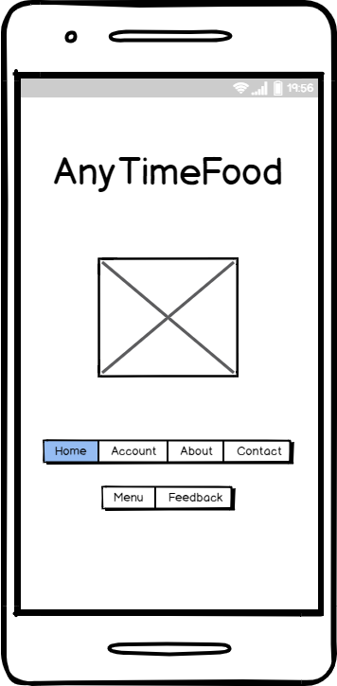

Ordering Process – Registration

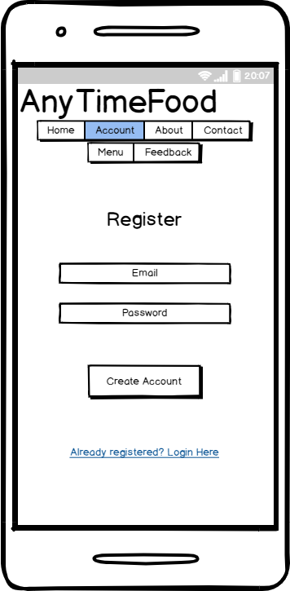

Order-Login

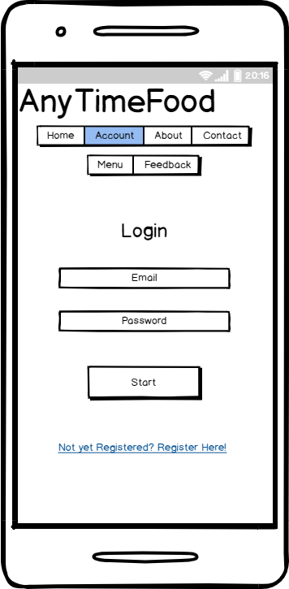

Order-Menu

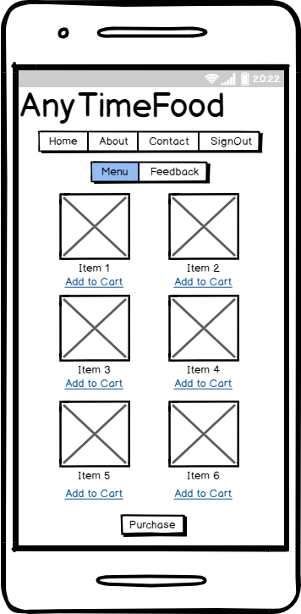

Order-ShippingInfo

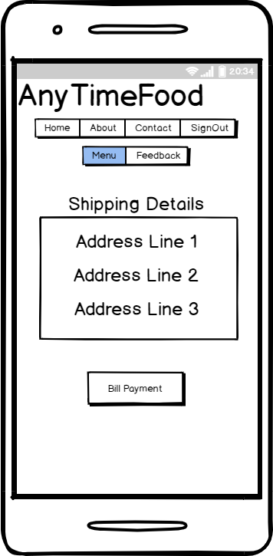

Order-BillingInfo

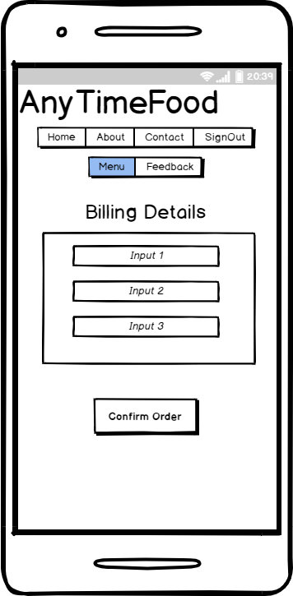

Order-Confirmed

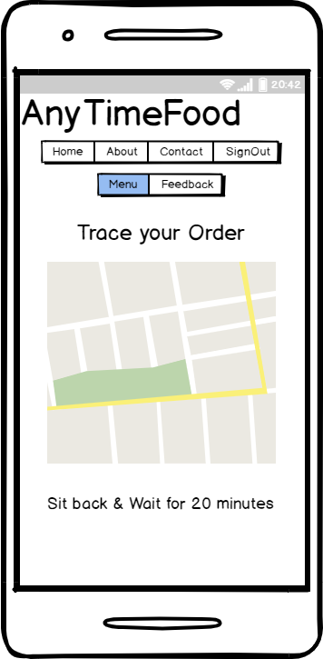

Additional Page – Contact

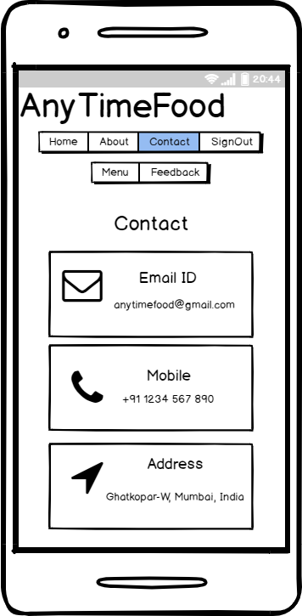

Homepage wireframe for desktop layout

